SMART PUBLIC RESTROOM

SUBMITTED BY:

M.Bhargav

REG NO;723921106006

EMAIL ID: kingofsoldierm170@gmail.com

A smart public restroom is a modern and innovative facility designed to enhance the user experience while optimizing efficiency and sustainability. This abstract describes the key features and benefits of such a restroom.

**Abstract**:

In our increasingly urbanized world, the need for efficient and user-friendly public restrooms has become paramount. The concept of a smart public restroom represents a cutting-edge approach to addressing this essential aspect of urban infrastructure. This abstract delves into the fundamental elements that make a restroom "smart" and explores the myriad advantages it offers to both users and the environment

**Handicapped persons use the smart public restroom why?**

Handicapped or differently-abled individuals can benefit from smart public restrooms for several reasons:

1. **Accessibility Features:** Smart public restrooms often come equipped with accessibility features designed to cater to people with disabilities. These features can include wider doorways, grab bars, accessible sinks, toilets, and changing tables, making it easier for individuals with mobility challenges to use the facilities independently.
2. **Touchless Fixtures:** Touchless faucets, soap dispensers, and hand dryers in smart restrooms are user-friendly for individuals with disabilities. They eliminate the need for precise hand movements and reduce the risk of contamination.
3. **Occupancy Indicators:** Smart restrooms may have occupancy indicators that help users quickly identify available accessible stalls. This feature can be particularly useful for wheelchair users who require the additional space provided by accessible restrooms.
4. **Automatic Flushing Toilets:** The automatic flushing feature in smart restrooms can be beneficial for people with disabilities who may have difficulty reaching or manipulating manual flush handles.
5. **Assistance Requests:** Some smart restrooms have features like call buttons or assistance requests that individuals with disabilities can use to request help from restroom attendants or staff.
6. **Universal Design:** The principles of universal design aim to create spaces that are accessible and usable by people of all abilities. Smart restrooms, when designed with universal design in mind, can provide a more inclusive and accommodating environment for everyone, including those with disabilities.
7. **Real-time Information:** Smart restrooms may provide real-time information about accessibility features and availability, helping individuals with disabilities plan their restroom visits more efficiently.

Overall, smart public restrooms can enhance the accessibility and convenience of restroom facilities for people with disabilities, promoting greater independence and a more inclusive experience for all restroom users. However, it's essential to ensure that these facilities meet all relevant accessibility standards and regulations to ensure equal access for individuals with disabilities

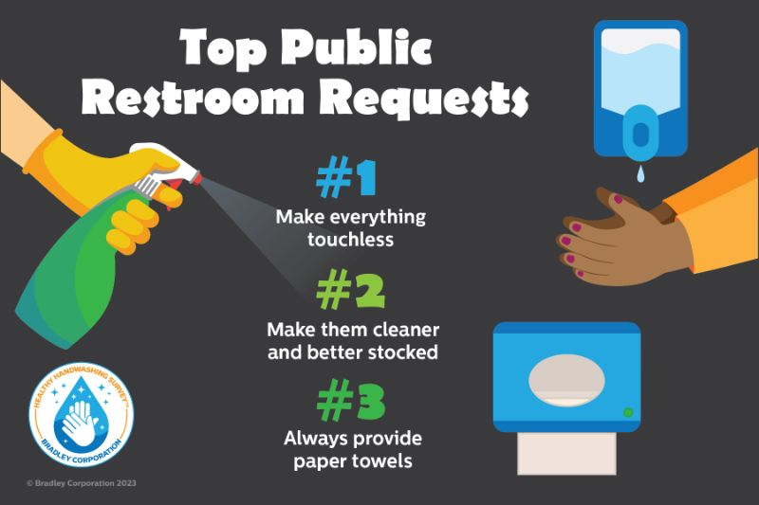

**INNOVATION :**

A smart public restroom refers to a technologically advanced and well-equipped public toilet facility that integrates various technologies and innovations to improve user experience, hygiene, and resource efficiency. These smart restrooms are designed to provide a higher level of convenience, cleanliness, and sustainability.

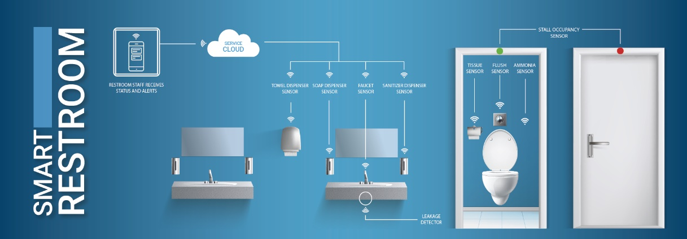

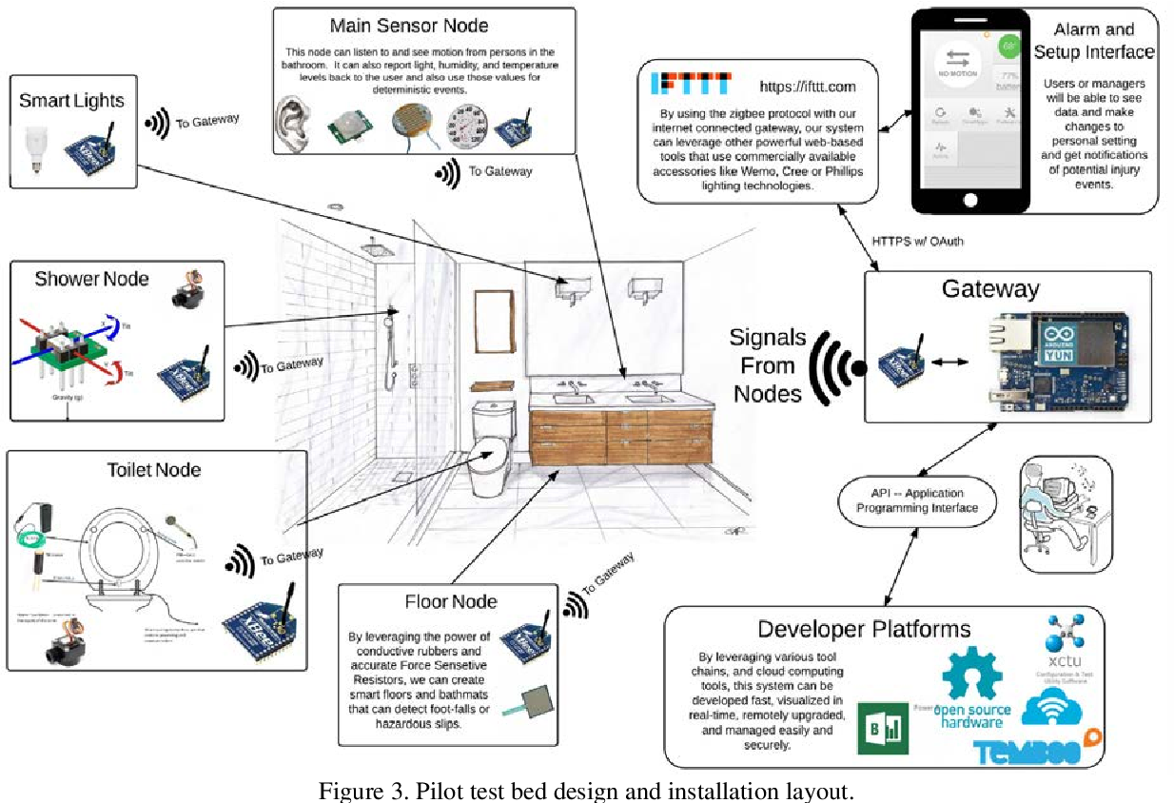

**What are the problems faced by the people in the public smart restroom ?**

1. **Technical Malfunctions:** Smart restroom equipment can experience technical issues, such as sensor malfunctions or system failures, leading to inconvenience and discomfort for users.
2. **Complexity:** The advanced features and technology in smart restrooms may confuse some users, especially those who are not familiar with touchless fixtures or other high-tech elements.
3. **Privacy Concerns:** Users may have concerns about the privacy implications of sensors and cameras used for monitoring and maintenance purposes. Ensuring privacy while maintaining security is a delicate balance.
4. **Maintenance Delays:** When smart restrooms require maintenance or cleaning, delays in response can result in unhygienic conditions or out-of-service facilities.
5. **Lack of Maintenance:** In some cases, the high-tech components may not be adequately maintained, leading to suboptimal performance, reduced hygiene, and functionality issues.
6. **Inadequate Accessibility:** Not all smart restrooms are designed with accessibility in mind, which can be problematic for users with disabilities who require features like wheelchair-accessible stalls or braille signage.
7. **Dependency on Electricity:** Smart restrooms rely on electricity to power sensors, lighting, and other features. Power outages can render some features nonfunctional, causing inconvenience.
8. **Limited Water Availability:** In areas with water scarcity, smart restrooms that offer automatic flush toilets and sensor-activated faucets may not be sustainable.
9. **Maintenance Costs:** Smart restroom facilities can be more expensive to build and maintain due to the technological components, and funding for upkeep may not always be available.

**Reliability:** Users may encounter inconsistencies in the performance of touchless fixtures and sensors, leading to frustration or confusion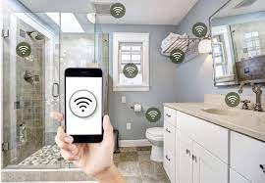

Creating a complete smart public restroom system in a single Python script is a complex task that may involve multiple components, sensors, and services. However, I can provide you with a simplified Python script that simulates a basic restroom occupancy system. This script will monitor the restroom's occupancy and display a message based on the occupancy status. Please note that this is a basic simulation and doesn't involve actual hardware or real-time data. In a real-world scenario, you would need sensors, databases, and communication with IoT platforms..

Creating a smart public restroom project using IoT devices and developing a Python script to manage these devices is a great idea. It can improve the efficiency and cleanliness of public restrooms. Here's a high-level outline of how you can approach this project:

**1. Selecting IoT Devices:**

Choose IoT devices and sensors that can help you monitor and manage various aspects of the restroom. Examples of IoT devices you may consider include:

* Occupancy sensors to track restroom usage.
* Smart locks for the restroom doors.
* Motion sensors to detect activity inside the restroom.
* Temperature and humidity sensors for climate control.
* Automated soap and sanitizer dispensers.
* Water usage monitoring devices.
* Surveillance cameras for security and monitoring.
* Air quality sensors.

**2. Hardware Setup:**

Set up the selected IoT devices in the restroom. Ensure they are connected to a local network or the internet, depending on your project requirements. You may need to consider power sources, such as batteries or electrical outlets, for your devices.

**3. IoT Platform:**

Choose an IoT platform to manage and collect data from your devices. Popular choices include AWS IoT, Google Cloud IoT, or platforms like Arduino IoT Cloud. Set up your devices on this platform and create channels for data collection.

**4. Python Script Development:**

Develop Python scripts to interact with and manage your IoT devices. These scripts will depend on the devices you are using, but here are some general tasks your Python scripts might perform:

* Collect data from the sensors, such as occupancy, temperature, humidity, or air quality.
* Send this data to the IoT platform for storage and analysis.
* Implement logic to control devices, such as smart locks for restroom access.
* Provide a user interface or control system for restroom administrators or maintenance staff.

**5. Data Processing and Analytics:**

Use the collected data for analytics and decision-making. For example, you can analyze restroom occupancy patterns to optimize cleaning schedules or adjust HVAC settings based on occupancy and environmental conditions.

**6. User Interface (Optional):**

Develop a user interface, such as a web application or mobile app, to allow administrators or even restroom users to interact with the system. This interface can provide real-time data and control options.

**7. Security and Privacy:**

Ensure that the IoT devices and data are secured to protect user privacy and prevent unauthorized access.

**8. Testing and Deployment:**

Thoroughly test your system in a controlled environment before deploying it in a public restroom.

**9. Maintenance and Updates:**

Plan for the long-term maintenance of your IoT devices and software. Updates and regular maintenance will be essential to keep the system running smoothly.

**10. Compliance and Regulations:**

Ensure your project complies with any local regulations and privacy laws related to public restroom monitoring and data collection.

Remember that this is a complex project, and each step may require in-depth technical knowledge and possibly collaboration with experts in IoT, software development, and hardware installation. It's important to plan and document your project carefully and consider scalability if you intend to deploy it in multiple locations.

import random

import time

def simulate_occupancy():

return random.choice(["Occupied", "Vacant"])

while True:

occupancy_status = simulate_occupancy()

if occupancy_status == "Occupied":

print("Restroom is occupied. Please wait.")

else:

print("Restroom is vacant. You can use it now.")

time.sleep(5) # Simulate checking the occupancy every 5 sec

**How people use smart public restroom?**

Top of FormSmart public restrooms are designed to enhance the user experience by incorporating technology and automation to improve cleanliness, efficiency, and convenience. Here are some common features and ways people use smart public restrooms:

1. **Touchless Fixtures:** Many smart restrooms have touchless faucets, soap dispensers, and hand dryers. Users can simply wave their hands or trigger sensors to activate these fixtures, reducing the spread of germs.
2. **Automatic Flushing Toilets:** Smart restrooms often include toilets with automatic flushing systems. Sensors detect when the user stands up, and the toilet **s** flushes automatically, promoting cleanliness and water conservation.
3. **OccupancySensor:** To indicate restroom availability, occupancy sensors on restroom doors or entryways can display whether the restroom is vacant or occupied, reducing the need to check each stall individually.
4. **LED Indicators:** Restroom stalls may have LED indicators above them, showing whether a stall is vacant or in use. This helps users quickly identify available stalls, improving efficiency.
5. **QR Codes or Apps:** Some smart restrooms offer QR codes that users can scan with their smartphones to access additional information, such as cleaning schedules, feedback forms, or even guided tours of the restroom facilities.
6. **Self-Cleaning Systems:** A few advanced smart restrooms are equipped with self-cleaning mechanisms. After each use, the toilet seat and bowl are cleaned automatically, and floors may be cleaned by robotic or automated systems.
7. **Real-time Feedback:** Users may be encouraged to provide feedback through digital interfaces or apps. This feedback can help restroom operators maintain and improve the facilities.
8. **Sustainability Features:** Smart restrooms often incorporate water-saving features, such as low-flow toilets and waterless urinals, to reduce water consumption. They may also use energy-efficient lighting and HVAC systems.
9. **Access Control:** Some smart restrooms require users to gain access through authentication methods, such as RFID cards or smartphone apps, ensuring that only authorized individuals can use the facilities.
10. **Maintenance Alerts:** Sensors and monitoring systems can detect issues like toilet paper or soap dispensers running low and automatically send alerts to maintenance personnel for refilling.
11. **Gender-Neutral and Family-Friendly Facilities:** Smart public restrooms may offer gender-neutral or family-friendly options to be more inclusive and accommodate diverse user needs.

Users can access these features by following the instructions provided in the restroom, such as waving a hand for soap or flushing, scanning QR codes, or simply using the fixtures as they normally would. The aim is to create a more hygienic, efficient, and user-friendly restroom experience.

A smart public restroom refers to a technologically advanced and well-equipped public toilet facility that integrates various technologies and innovations to improve user experience, hygiene, and resource efficiency. These smart restrooms are designed to provide a higher level of convenience, cleanliness, and sustainability.

Smart public restrooms can benefit from web development technologies in various ways to enhance user experience, maintenance, and resource management. Here's how web development technologies can be applied:

1. **Occupancy Monitoring**:
   * Web-connected sensors can monitor restroom occupancy. Web development technologies enable real-time updates of restroom availability on mobile apps or websites, helping users find vacant facilities.
2. **Mobile Apps**:
   * Web development frameworks like React Native or Flutter can be used to create mobile apps that allow users to find nearby smart restrooms, check occupancy, and receive notifications.
3. **User Interface (UI)**:
   * Web development technologies like HTML, CSS, and JavaScript are used to design user-friendly interfaces for touchscreen displays within restrooms. These interfaces may include options for selecting different amenities, reporting issues, and providing feedback.
4. **IoT Integration**:
   * IoT devices within restrooms (e.g., smart faucets, soap dispensers, and paper towel dispensers) can be connected to the web for data collection and remote management. Web APIs enable communication between these devices and a central control system.
5. **Maintenance and Cleaning Scheduling**:
   * Web applications can help facility managers schedule cleaning and maintenance based on real-time data, usage patterns, and user feedback. This improves restroom cleanliness and efficiency.
6. **QR Code or NFC Access**:
   * Web development technologies can be used to create QR code or NFC-based access systems, allowing users to enter restrooms securely through their smartphones.
7. **Feedback and Reporting**:
   * Users can report issues or provide feedback through web-based forms or mobile apps. These reports can be sent to facility managers for prompt resolution.
8. **Resource Management**:
   * Web applications can help track resource usage (e.g., water and electricity) in real-time, optimizing resource efficiency and reducing costs.
9. **Data Analytics and Insights**:
   * Web technologies are essential for processing and visualizing restroom usage data, providing insights into traffic patterns and usage trends.
10. **Payment and Access Control**:
    * Web technologies enable payment processing for premium restrooms, access control for secure entry, and integration with payment gateways.
11. **Security and Privacy**:
    * Implementing secure authentication and data encryption using web development technologies is crucial to protect user data and ensure privacy.
12. **Alerts and Notifications**:
    * Automatic alerts can be sent to facility managers for issues like restroom overuse, water leaks, or equipment malfunctions. These alerts can be delivered via email, SMS, or push notifications.
13. **Accessibility Features**:
    * Web development technologies should ensure accessibility features for people with disabilities, including screen readers and support for different input methods.

Overall, web development technologies play a significant role in creating a seamless and efficient experience in smart public restrooms, from monitoring occupancy to providing user-friendly interfaces and data-driven management. These technologies contribute to improved hygiene, resource conservation, and user satisfaction.

Top of Form

Regenerate

**Benefits:**

1. **Enhanced User Experience:** Users encounter a clean, well-maintained facility with minimal wait times. Customizable settings cater to individual preferences, enhancing overall comfort.
2. **Sustainability:** Smart restrooms significantly reduce water and energy consumption, contributing to sustainability goals and reducing operating costs for municipalities.
3. **Public Health:** Advanced sanitation and touchless amenities help maintain a high standard of hygiene, which is critical in densely populated areas.
4. **Data-Driven Maintenance:** Real-time data collection enables predictive maintenance, reducing downtime and ensuring continuous service availability.
5. **Innovation Showcase:** Smart public restrooms serve as a symbol of technological advancement and urban modernization, attracting residents and tourists alike.

In conclusion, the smart public restroom represents a forward-thinking approach to address the essential needs of urban populations. By integrating technology, automation sustainability, and user-centric design, these facilities promise to revolutionize the way we experience and manage public restrooms, ultimately enhancing the quality of urban life.

Users can access these features by following the instructions provided in the restroom, such as waving a hand for soap or flushing, scanning QR codes, or simply using the fixtures as they normally would. The aim is to create a more hygienic, efficient, and user-friendly restroom experience.

Overall, smart public restrooms can enhance the accessibility and convenience of restroom facilities for people with disabilities, promoting greater independence and a more inclusive experience for all restroom users. However, it's essential to ensure that these facilities meet all relevant accessibility standards and regulations to ensure equal access for individuals with disabilities.

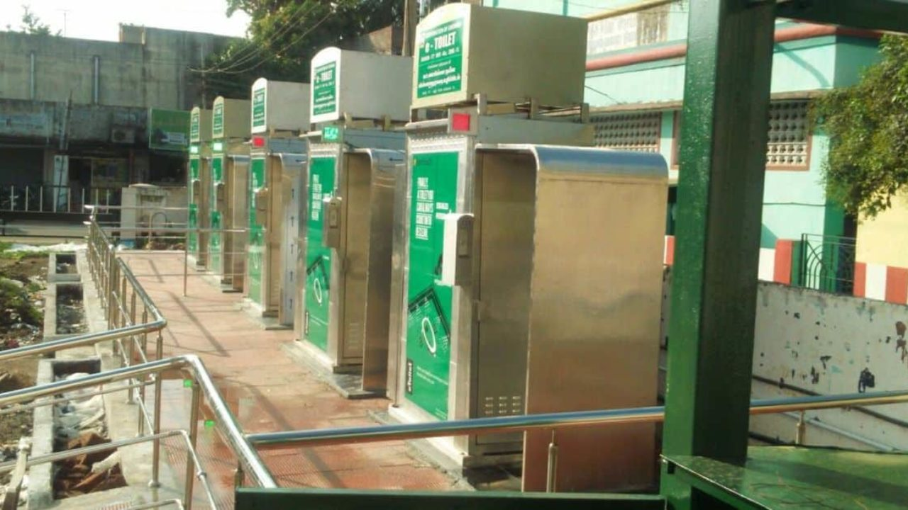Bottom of Form